You are given an integer array matchsticks where matchsticks[i] is the length of the ith matchstick. You want to use **all the matchsticks** to make one square. You **should not break** any stick, but you can link them up, and each matchstick must be used **exactly one time**.

Return true if you can make this square and false otherwise.

**Example 1:**

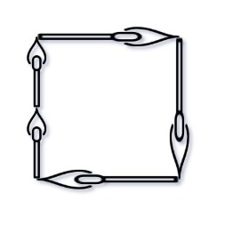

**Input:** matchsticks = [1,1,2,2,2]

**Output:** true

**Explanation:** You can form a square with length 2, one side of the square came two sticks with length 1.

**Example 2:**

**Input:** matchsticks = [3,3,3,3,4]

**Output:** false

**Explanation:** You cannot find a way to form a square with all the matchsticks.

**Constraints:**

* 1 <= matchsticks.length <= 15
* 1 <= matchsticks[i] <= 108